PowerShell Accessing SQL Server

Part 1: Running the Lab
Walk through each step in order, running the corresponding script section and capturing the listed screenshot before moving on. Run everything from the project root folder so relative paths like .\data\students.xml resolve correctly.

Step 01 — Create the Project Folder
Create a dedicated folder for this lab. This keeps scripts, screenshots, and docs organized.
mkdir PowerShell-Accessing-SQL-Server
cd PowerShell-Accessing-SQL-Server
mkdir scripts, screenshots, docs
Open the folder in File Explorer or VS Code (code .) and confirm you see scripts, screenshots, and docs subfolders.
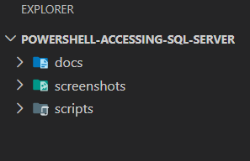
File Explorer showing this folder structure.

Step 02 — Install the MySQL Connector/NET
Download / (https://downloads.mysql.com/archives/c-net/) and install mysql-connector-net-8.1.0.msi (this provides the MySql.Data.dll used to connect from PowerShell).

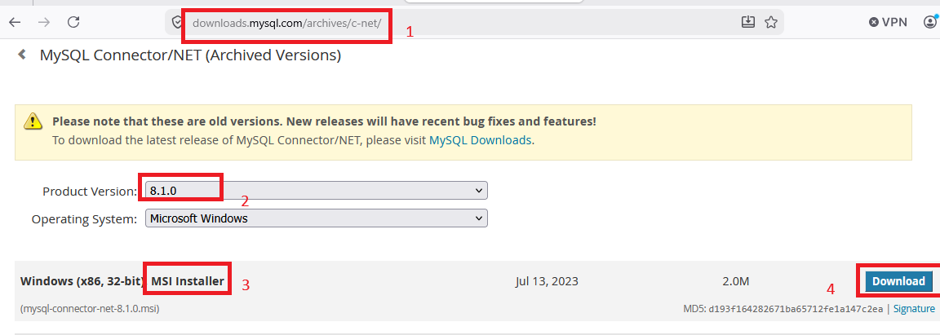

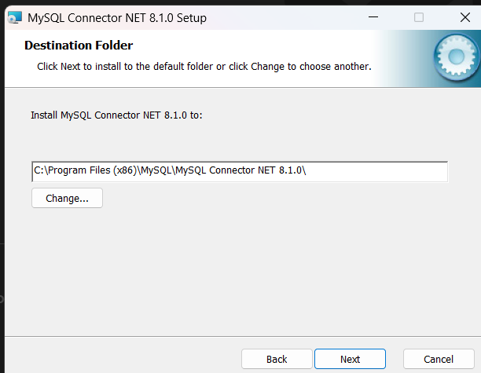

Note the install path — it's usually C:\Program Files (x86)\MySQL\MySQL Connector NET 8.1.0\.
Confirm the installer completed and MySql.Data.dll exists at the installed path.

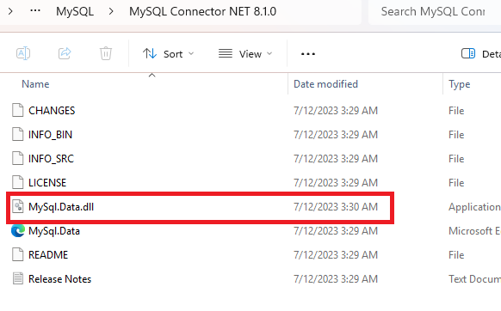Installer completion screen or File Explorer showing MySql.Data.dll in the install folder.

Step 03 — Create the Connection Script
Create scripts\Task1-Connect-SQLServer.ps1. Load the connector assembly and build the connection string with your own server, username, and password.
Replace ServerName, ps-learner, and samplepassword with your actual database server details before running.
# Create connection string
$connectionString = "Server=localhost;Database=master;Trusted_Connection=True;"

# Create connection
$connection = New-Object System.Data.SqlClient.SqlConnection
$connection.ConnectionString = $connectionString

try {
# Open the connection
$connection.Open()
Write-Host "Successfully connected to the database server." -ForegroundColor Green
}
catch {
Write-Host "Error: $_" -ForegroundColor Red
}
Replace ServerName, ps-learner, and samplepassword with your actual database server details before running.

Step 04 — Verify the Connection
Add the connection-state check to the same script and run it.
Expected console output: Connected to SQL Server

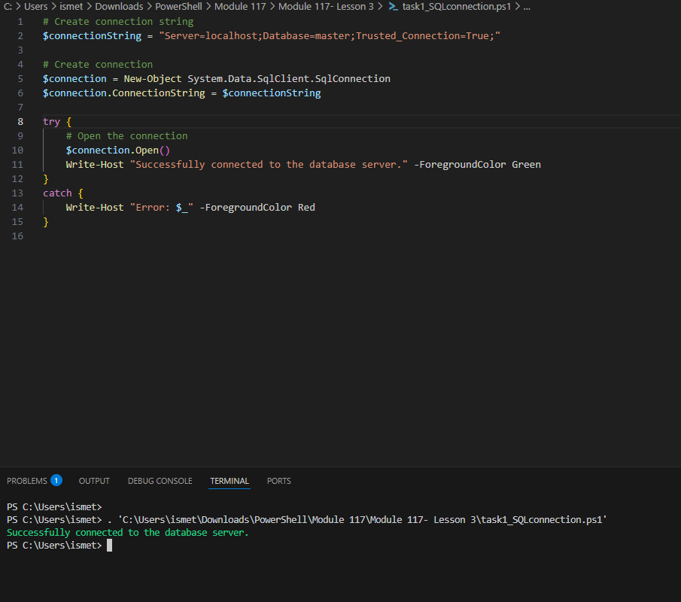Script open in VS Code showing the connection string and Terminal showing the successful connection message.

Step 05 — List Available Tables
Create scripts\Task2-Query-Data.ps1. Run a SHOW TABLES command to confirm the Students table exists in the database.
Expected output: a list of table names, including Students.
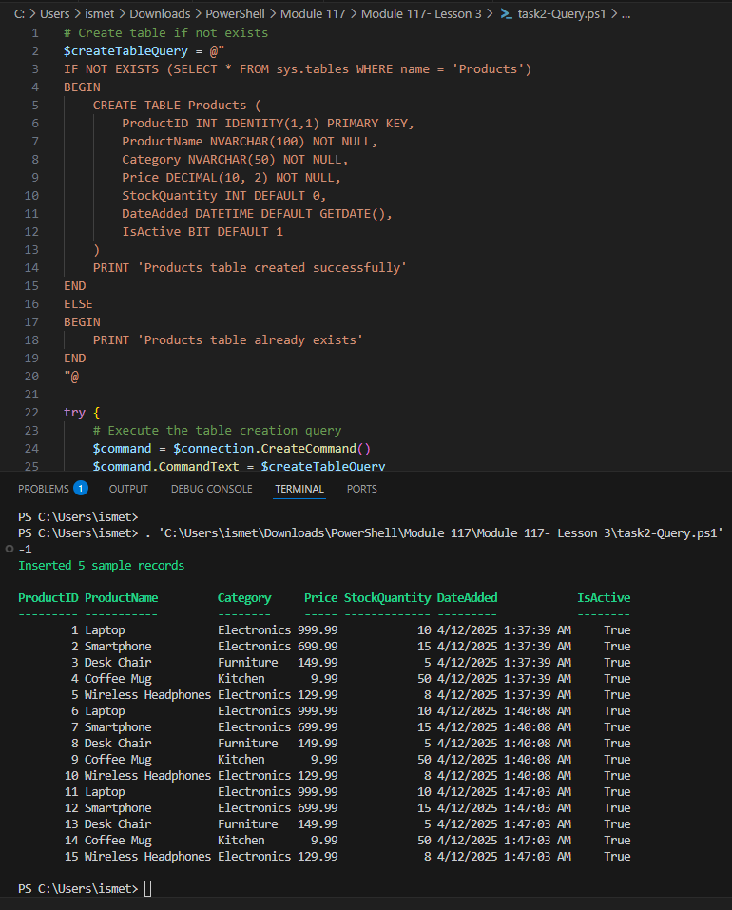Terminal output listing the available tables.

Step 06 — Query Specific Data
Still in Task2, run a SELECT query against the Students table and display the results.
$query = "SELECT * FROM Students"
$command = $connection.CreateCommand()
$command.CommandText = $query
$reader = $command.ExecuteReader()
while ($reader.Read()) {
Write-Host "Name: $($reader["name"]), Age: $($reader["age"]), Grade: $($reader["grade"])"
}
$reader.Close()
Expected console output: Name: John Micheal, Age: 20, Grade: A Name: Jon Mike, Age: 21, Grade: B Name: Sara Ahmed, Age: 19, Grade: A

Step 07 — Close the Connection
Add $connection.Close() at the end of the script and run the full Task1 + Task2 flow end-to-end to confirm everything works in sequence with no errors.
$connection.Close()
Expected: script runs from connection to query to close with no errors or red text in the console.

Step 08 — Verify Final Files
Open File Explorer at the project root and confirm scripts/ has both Task1-Connect-SQLServer.ps1 and Task2-Query-Data.ps1, and screenshots/ has all your captures.

